PRESS RELEASE, NOVEMBER 2023

Experience the future of manufacturing at FANUC’s Open House
Opening its doors to manufacturers of all shapes and sizes, FANUC UK will showcase the future of manufacturing at its annual Open House event in Coventry next week (14-16 Nov 2023, Ansty Park, Coventry). Combining real-world case studies, high-level panel debates, Q&A sessions, plus hands-on robot training, live demos and a vibrant exhibition area, this year’s Open House promises to be the highlight of the automation calendar. FANUC’s free-to-attend event will offer insights and solutions from industry leaders to some of the biggest challenges facing manufacturers today, including productivity, sustainability, labour shortages and upskilling. Across three days, a packed seminar programme will uncover the benefits of automation and robotics for modern manufacturers, with the event culminating in the WorldSkills UK industrial robotics live final. Here’s the day-by-day breakdown of just what’s in store at FANUC’s Open House 2023…
Day 1 – The future of UK manufacturing
FANUC UK’s Managing Director, Tom Bouchier, will kick off the event on Tuesday 14th November with a summary of the current state of automation uptake in the UK. This is followed by a panel discussion featuring industry thought leader Stuart Whitehead of the Jefferson Group and senior representatives from FANUC UK and Europe, focusing on breaking down barriers to automation.
The Institute of Advanced Manufacturing will then reveal their ultra-smart ‘Omnifactory’ approach to manufacturing, followed by a deep dive into cobot market trends by FANUC’s Paul Richards. The morning sessions culminate with a panel discussion on busting the automation myths with the PPMA’s Peter Williamson, Gary Herbert from Rockwell Automation, FANUC’s Carl Patrick and Martin Kidman from SICK.
Day 2 – Sustainable manufacturing
Incorporating sustainability into every facet of the manufacturing supply chain is the focus for day two, which begins with a session on total cost of ownership by FANUC’s Oliver Selby. Tom Mott from Rockwell Automation will then enlighten the audience on how to help their customers become more productive and sustainable, before CHG’s Peter Clarke reveals how to use data to increase sustainability.
A real-world case study from Recycleye will showcase the benefits of automation for the waste sector, while a panel discussion on the importance of putting sustainability at the forefront of manufacturing plans rounds off the day two sessions.
Day 3 – Education, education, education
The final day of the FANUC Open House focuses on the next generation of engineers, with a variety of exciting presentations set to showcase the benefits of a career in manufacturing. Current apprentices will reveal their real-life experiences, while previous winners and participants of the WorldSkills UK industrial robotics competition will outline the impact the initiative has had on shaping their future.
The seminar programme ends with a panel debate on closing the gap between industry and education, featuring insight from the MTC’s Mike Wilson and Rockwell Automation’s Tom Mott, among others.
Hands-on robot training
While each morning will be given over to high-level presentations and debates, the Open House afternoon sessions present the chance for visitors to get up close and personal with the latest automation and robotics technology. Robot training taster sessions, live demos, and a 30-strong exhibition area featuring innovative automation solutions from across the manufacturing sphere will allow manufacturers to see for themselves the benefits that automation can bring to their production lines. Culminating in the live final of the 2023 WorldSkills UK industrial robotics competition, the FANUC UK Open House event is not to be missed.
For the full agenda and to register your attendance at the FANUC Annual Open House (14-16 November 2023, Ansty Park, Coventry), go to https://ukopenhouse.fanuc.eu

<ENDS>
NOTES FOR EDITORS
Images & Captions

Image 1
Opening its doors to manufacturers of all shapes and sizes, FANUC UK will showcase the future of manufacturing at its annual Open House event in Coventry next week from 14-16th November
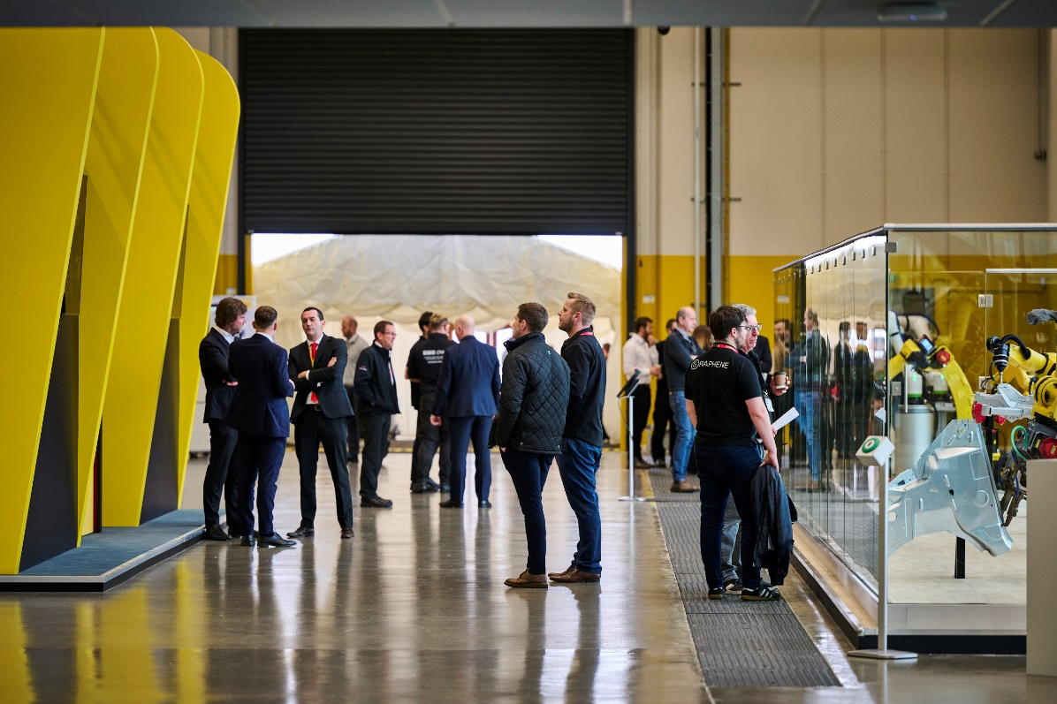

Image 2
The Open House afternoon sessions present the chance for visitors to get up close and personal with the latest automation and robotics technology.
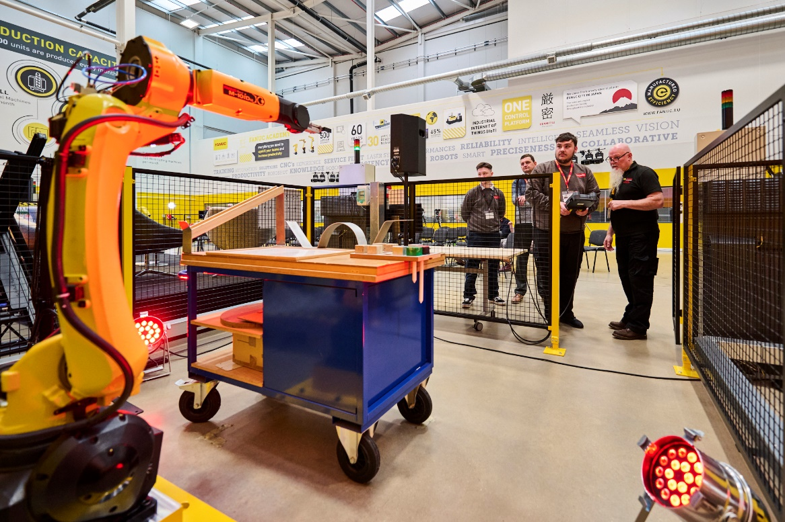

Image 3
The event features a 30-strong exhibition area featuring innovative automation solutions from across the manufacturing sphere will allow manufacturers to see for themselves the benefits that automation can bring to their production lines.
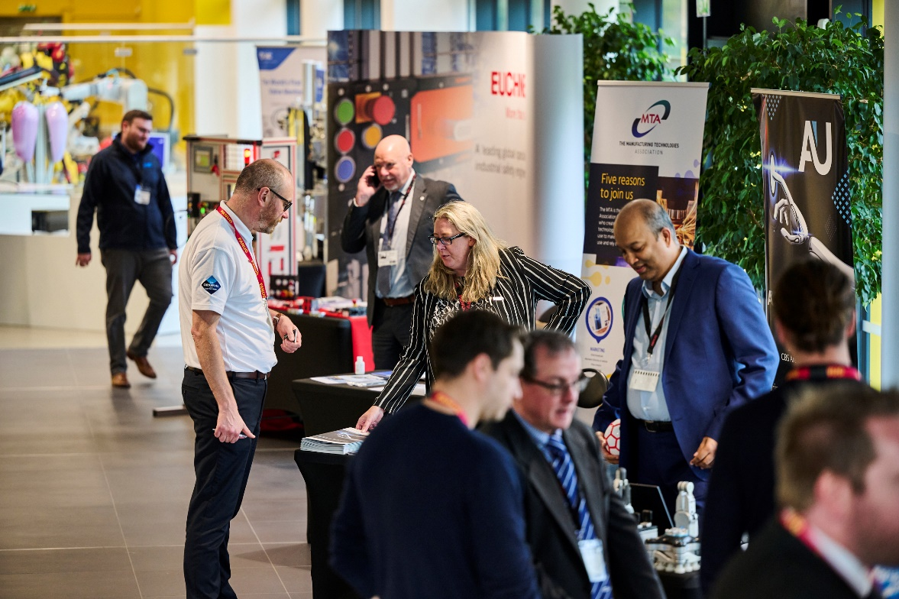

About FANUC
The FANUC Corporation is a global leader in industrial automation, supplying CNC control systems, robots, cobots, and production machinery (ROBODRILL, ROBOCUT and ROBOSHOT) to factories around the world. Since 1955, FANUC has made a significant contribution to the efficiency and productivity of manufacturing companies worldwide. Operating in more than 270 locations globally and serving more than 100 countries with over 9,000 employees, FANUC offers a dense network in sales, technical support, research & development, logistics and customer service.

For more information, please contact:
FANUC UK Ltd
Sapphire Way, Ansty Park, COVENTRY, CV7 9DR
Phone: +44 (0) 24 7605 3130
Email: marketing@fanuc.co.uk
www.fanuc.eu/uk/en

Press release issued for FANUC UK Ltd by FastLoop Media:

Lucy Benbow, FastLoop Media
T +44 (0)7971 987761 E lucy@fastloopmedia.com
W www.fastloopmedia.com

Kate O’Reilly, FastLoop Media, Managing Director
T +44 (0)7894 039 609 E kate@fastloopmedia.com
W www.fastloopmedia.com

